Sample Social Media posts

EXAMPLE POST 1
I’ve recently become involved in an exciting new programme called Inspiring the Future that has been created to broaden young people’s horizons, and help challenge stereotypes that can limit their potential.
Inspiring the Future events are hosted by schools and at them students hear from people in all sorts of different jobs – the programme is based on research that showed young people in Aotearoa New Zealand have a narrow view of what opportunities are out there for them.
Inspiring the future needs people from different walks of life to share their stories and I encourage anyone, in any job to sign-up to be a role model.
Find out more at inspiringthefuture.org.nz
#InspiringTheFutureNZ

Share the Inspiring the Future brand video with this post: https://www.youtube.com/watch?v=sfBvGwloz2A

EXAMPLE POST 2
Most children under 13 see themselves in just one of nine different jobs. Do you think your job is one of these?
Probably not, and that’s why you can help open young people’s eyes to the opportunities out there.
Inspiring the Future is an exciting new programme coming to schools where volunteers talk to students about their job and their journey. I’m volunteering to be a role model and you can too – you can showcase your job and your industry while inspiring children.
Find out more at inspiringthefuture.org.nz
#InspiringTheFutureNZ
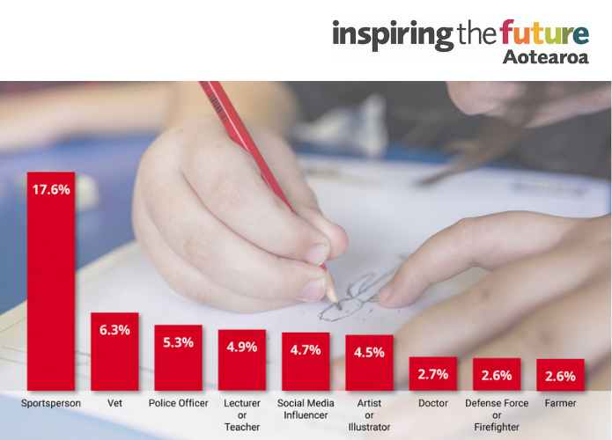

EXAMPLE POST 3
Join me in showing Aotearoa’s tamariki the possibilities for their futures!
Research shows that our young people’s aspirations are narrow, and stereotypes are holding them back. So I’m volunteering to be a role model at Inspiring the Future events to tell my story and help show children what jobs are out there. They can’t be what they can’t see.
Help me broaden our young people’s aspirations and challenge those stereotypes. Find out more about volunteering to be a role model at inspiringthefuture.org.nz
#InspiringTheFutureNZ

EXAMPLE POST 4
Children are particularly influenced by the exposure they have to different careers, and research shows that exposure is currently limited.
That’s why I’m very excited about Inspiring the Future, a new programme where volunteer role models talk to students about their jobs and their journeys.
Your story could inspire a young person! Anyone, in any job can be a role model - Inspiring the Future needs people from all different walks of life.
Find out more at inspiringthefuture.org.nz
#InspiringTheFutureNZ

EXAMPLE POST 5
Have you heard about Inspiring the Future?
It’s an exciting new programme where people from the community share their stories with young people to help broaden their horizons and challenge stereotypes.
If you’ve heard about it but haven’t signed-up to be a role model yet then here’s a few things to remember:
- There are both in-person and online events so that you can take part no matter where you are
- If a school invites you to an event and you can’t make it that day, you can decline
- There are resources and guides at every step so it’s easy and fun
No matter what job you do, or what your story is, you can inspire someone. Sign-up with me at inspiringthefuture.org.nz/sign-up/role-models
#InspiringTheFutureNZ

Share this video of an Inspiring the Future trial event: https://youtu.be/clWMZI4wQLI

EXAMPLE POST 6
Our childhood aspirations shape the career choices we make as adults. The Tertiary Education Commission's Drawing the Future research discovered some concerning insights about the future of a number of industries.
You can help change these findings! Showcase your job to young people and tell them your story at Inspiring the Future events. This is a new programme coming to schools in Term 2 that broadens children’s horizons and challenges the stereotypes holding them back.
With just a few hours of you time, you can inspire someone. Sign-up to be a role model with me at inspiringthefuture.org.nz/sign-up/role-models
#InspiringTheFutureNZ

