Intranet article

What is Inspiring the Future?
Inspiring the Future is an exciting programme that’s coming soon to schools across New Zealand – including schools in our community, and we’d like you to take part.
At an Inspiring the Future event young people learn about different jobs and why people love doing them, as well as how those people got started in their careers.
Watch the video

Why Inspiring the Future?
In 2019, students aged 7 to 13 from across Aotearoa drew pictures of what they wanted to be when they grew up.
The results show that young people often have narrow ideas about the future. More than half of the students wanted to do one of just nine most popular jobs.

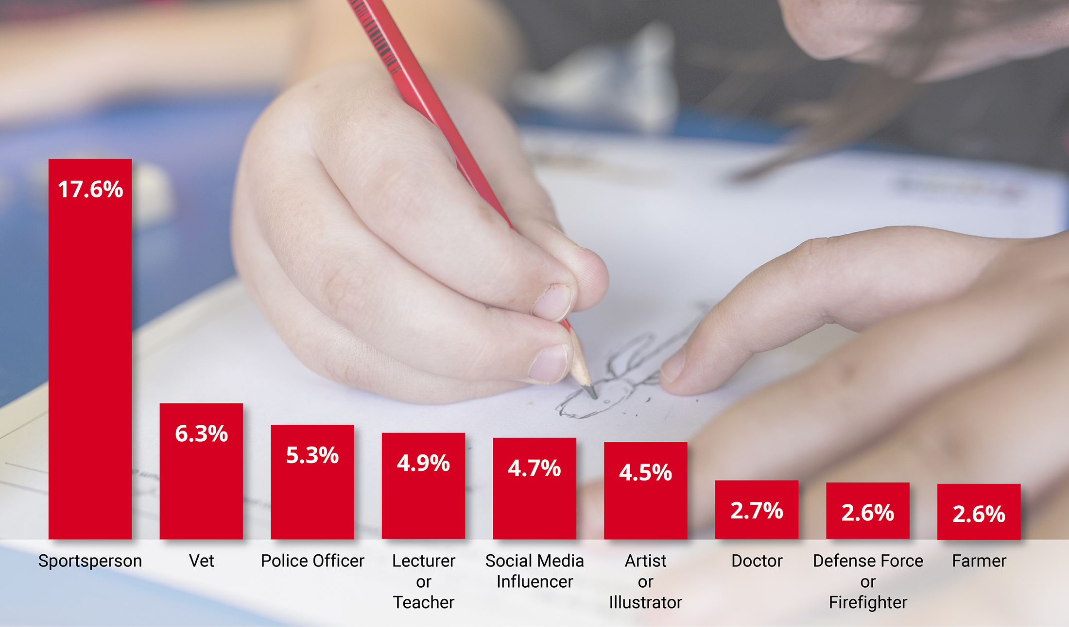

The findings also revealed patterns of unconscious bias that can limit young people’s aspirations.
- Boys are nine times more likely than girls to want to work in a trade, and four times more likely to aspire to be an engineer.
- Girls are two and a half times more likely than boys to aspire to work in the arts.
- Children at lower decile schools were less likely than those at higher decile schools to aspire to careers in science, technology, engineering and maths.

Less than 1% of young people knew about their preferred role from someone visiting their school from the world of work.

Inspiring the Future has been created to broaden young people’s horizons and help challenge stereotypes that limit their potential by bridging the gap between the world of work and school.

Why should I volunteer?
By taking part, you can showcase your job and our industry to the community while opening children’s eyes to more of the possibilities.
Speaking at an in-school event is a great opportunity for professional development. It will help us raise the profile of our business and demonstrate that our business is a socially responsible one, by engaging with our community and contributing to its ongoing wellbeing.

Next steps
When you sign up to be an Inspiring the Future role model, you’ll be asked to complete an online profile and a criminal record check form.
Your profile will be visible to schools on the website after the criminal record check. Teachers can then read your profile and invite you to participate in Inspiring the Future events.

Your time commitment
Inspiring the Future events last up to 4-5 hours. You should allow time to travel to and from the event and up to 1 hour for preparation.
If a school invites you to their Inspiring the Future event, you’ll receive an email asking you to log in to the website and find out more.
Signing up as a role model doesn’t mean you have to participate in events. You can accept or decline as many event invitations as you wish based on your availability.

For more information contact <INSERT NAME>
Insert your name, or the name of someone in your organisation that backs Inspiring the Future, so your colleagues can ask questions.

How do I sign up?
Sign up at inspiringthefuture.org.nz

