Sample Social Media posts

EXAMPLE POST 1
Want to showcase your industry and the work you do?

At an Inspiring the Future event, young people hear from people in their own communities, learn about different jobs and why people love doing them.
Find out why tamariki need you to share your story at an Inspiring the Future event. Watch the video
#InspiringtheFutureNZ

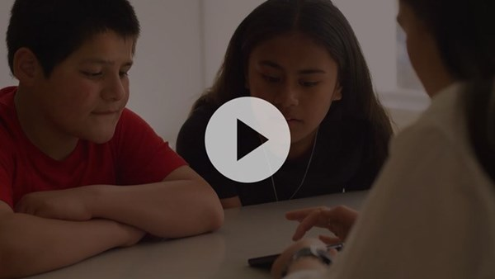

EXAMPLE POST 2
Share your story and help young people in your community learn about different jobs and why people love doing them. Sign up to be a role model
#InspiringtheFutureNZ

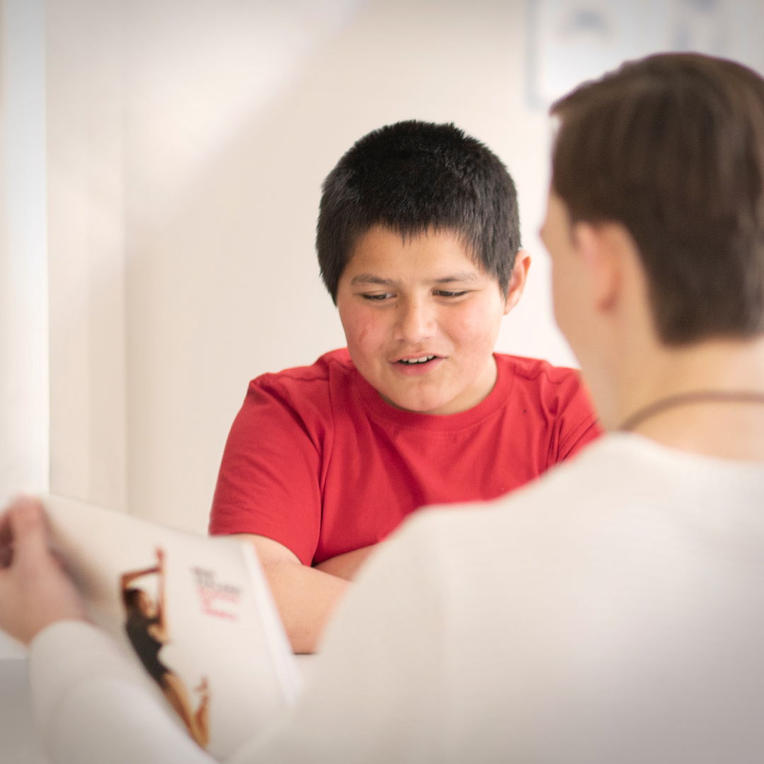

EXAMPLE POST 3
Encourage your colleagues to participate
At an Inspiring the Future event, young people hear from people in their own communities, learn about different jobs and why people love doing them, as well as how those people got started in their careers.
Inspiring the Future offers businesses like yours an opportunity to demonstrate that your business is a socially responsible one, whilst raising the profile of your job role and industry.
Sign up to be a role model
#InspiringtheFutureNZ

EXAMPLE POST 4
Share your story and help young people in your community learn about different jobs and why people love doing them. Sign up to be a role model
#InspiringtheFutureNZ

EXAMPLE POST 5
Inspiring the Future is a powerful experience where your story can give young people a new sense of the possibilities. Be someone’s inspiration. Sign up to be a role model
#InspiringtheFutureNZ

EXAMPLE POST 6
Share your story and help young people in your community learn about different jobs and why people love doing them. Sign up to be a role model
#InspiringtheFutureNZ

EXAMPLE POST 7
Children can’t be what they can’t see.

If they don’t hear stories like yours, our young people might never know how many possibilities are available to them.
Watch the video
#InspiringtheFutureNZ

EXAMPLE POST 8
Based on research from Aotearoa and overseas, Inspiring the Future has been created to broaden young people’s horizons, help challenge stereotypes and address unconscious biases that can limit their potential.
Watch an Inspiring the Future event in action
#InspiringtheFutureNZ

