Share your story and help broaden young people’s horizons
Inspiring the Future is an exciting new programme for schools across Aotearoa New Zealand that has been created to broaden young people’s horizons, and help challenge stereotypes that can limit their potential.
At an Inspiring the Future event young people learn about different jobs and why people love doing them, as well as how those people got started in their careers.
There are in-person and online event options so that people have the opportunity to take part no matter where they live.
Anyone, in any job, can be a role model and you can too!
Inspiring the Future needs people from different walks of life to share their stories, and any challenges they had to overcome to be where they are now.
You can sign-up to be a role model at inspiringthefuture.org.nz

Why Inspiring the Future?
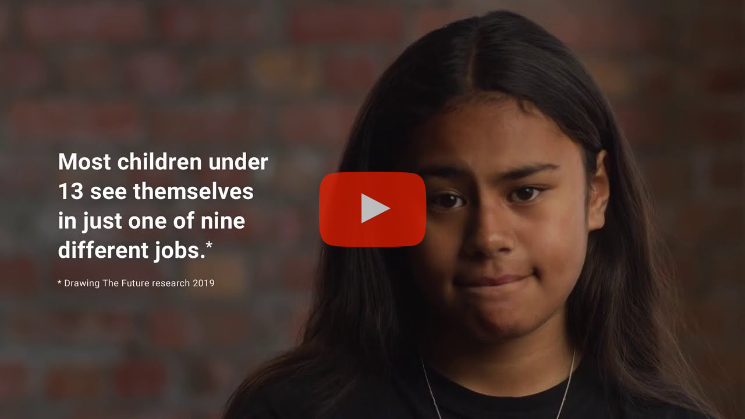
Watch the video
Drawing the Future is a national survey commissioned by the Tertiary Education Commission in October 2019. Students aged 7 to 13 were asked to draw a job they wanted to do when they grew up.
The results found that more than half of young people aged 7 to 13 see themselves in one of just nine most popular jobs, as well as patterns of unconscious bias about gender, ethnicity and socio-economic status.

Showcase your job and our industry
By taking part, you can showcase your job and our industry to the community while opening children’s eyes to more of the possibilities.
Speaking at an in-school event is a great opportunity for professional development. It will also help raise the profile of our business and demonstrate that our business is a socially responsible one, by engaging with our community and contributing to its ongoing wellbeing.

How it works
When you sign up to be an Inspiring the Future role model, you’ll be asked to complete an online profile and a criminal record check form.
Your profile will be visible to schools on the website after the criminal record check. Teachers can then read your profile and invite you to participate in Inspiring the Future events.
Signing up as a role model doesn’t mean you have to participate in events. You can accept or decline as many event invitations as you wish based on your availability.
This video will give you an idea of what an in-person event is like.
And you get support and resources every step of the way, so it’s easy and fun!

Your time commitment
In-person Inspiring the Future events last up to 4-5 hours, and online events last 1-2 hours plus a half hour pre-meet.

For more information contact <INSERT NAME> or visit inspiringthefuture.org.nz

